**FOURIER SERIES OF CONTINUOUS**

**TIME SIGNALS**

**LAB # 10**



**Spring 2023**

**CSE301L Signals & Systems Lab**

Submitted by: **Ali Asghar**

Registration No. : **21PWCSE2059**

Class Section: **C**

“On my honor, as student of University of Engineering and Technology, I have neither given nor received unauthorized assistance on this academic work.”

Submitted to:

**Engr. Sumayyea Salahuddin**

Date:

**June 13, 2023**

**Department of Computer Systems Engineering**

**University of Engineering and Technology, Peshawar**

## Lab Objective(s):

Objectives of this Lab are;

* Fourier Series Representation of Continuous Time Period Signals
* Convergence of Continuous Time Fourier Series

## Task # 01:

In above example, ak’s are chosen to be symmetric about the index k=0, i.e. ak = a‐k. Select new ak’s on your own to alter this symmetry and form the new signal. What do you observe? Is x(t) a real signal when coefficients are not symmetric?

**Problem Analysis:**

To observe fourier representation of continuous time signal.

**Algorithm:**

* Write code
* Execute Code
* Record Results

**Output / Graphs / Plots / Results:**

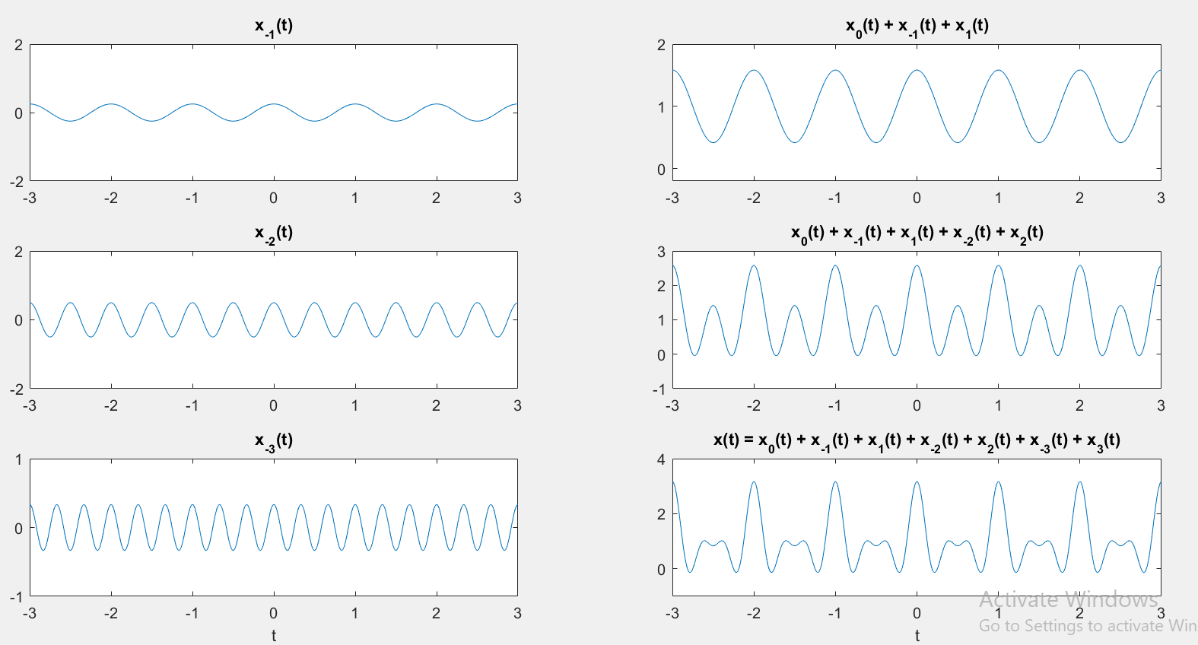

**Discussion and Conclusion:**

When the coefficients are not symmetric, the resulting signal is no longer purely real. The original signal had symmetry, meaning the coefficients for k and -k were equal, resulting in a real signal. However, by changing the coefficients for k = -1 and k = 1, the symmetry is broken, and the resulting signal contains complex components. This is evident from the imaginary parts of the signal components in the plots.

## Task # 02:

A discrete‐time periodic signal x[n] is real valued and has a fundamental period of N = 5. The non‐zero Fourier series coefficients for x[n] are:



Express x[n] as linear combination of given coefficients.

**Problem Analysis:**

Fourier series representation of a discrete signal.

**Algorithm:**

* Write code
* Execute Code
* Record Results

**Output / Graphs / Plots / Results:**

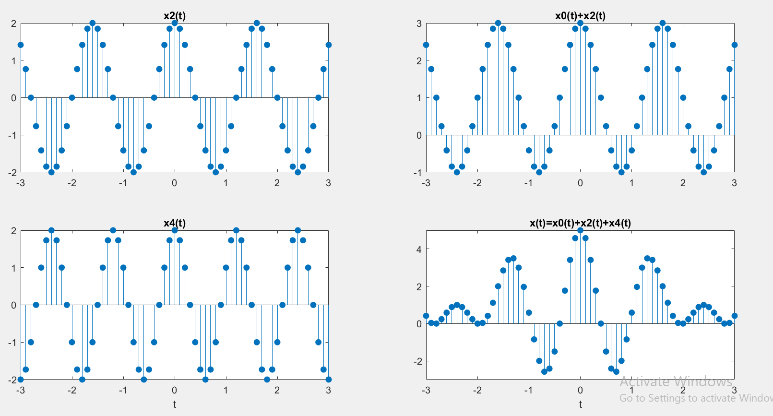

**Discussion and Conclusion:**

We represented a discrete signal in fourier series.

## Task # 03:

Considering the FS coefficients plot given below, what do you observe happens to the envelope of the coefficients when T1 is reduced from 1/4 to 1/16 with constant time period T?

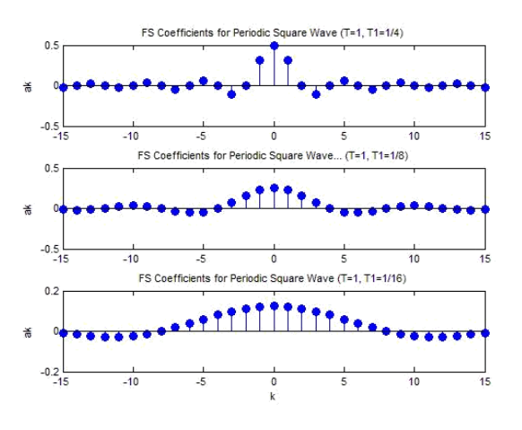

**Problem Analysis:**

To change FS Coefficients of a periodic square wave.

**Algorithm:**

* Write code
* Execute Code
* Record Results

**Output / Graphs / Plots / Results:**

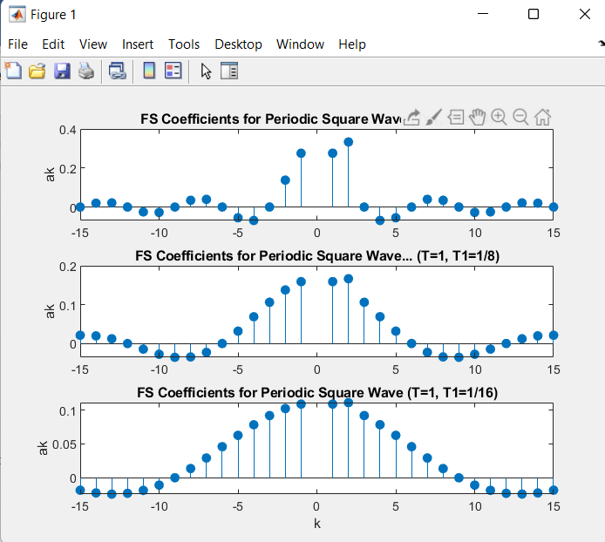

**Discussion and Conclusion:**

When the time period T1 is reduced, it means that the frequency associated with that particular harmonic component increases. In the context of Fourier Series, the higher the frequency of a harmonic component, the faster it oscillates.

Reducing T1 from 1/4 to 1/16 with constant time period T implies increasing the frequency of the harmonic component corresponding to T1. As a result, the envelope of the coefficients is expected to become more tightly packed or compressed.

## Task # 04:

Create the plots of square wave reconstructed using M = 10, 20, & 100 terms above, what do you observe about Gibb’s phenomena?

**Problem Analysis:**

Changing M variable in a square wave to observe gibbs phenomenon.

**Algorithm:**

* Write code
* Execute Code
* Record Results

**Output / Graphs / Plots / Results:**

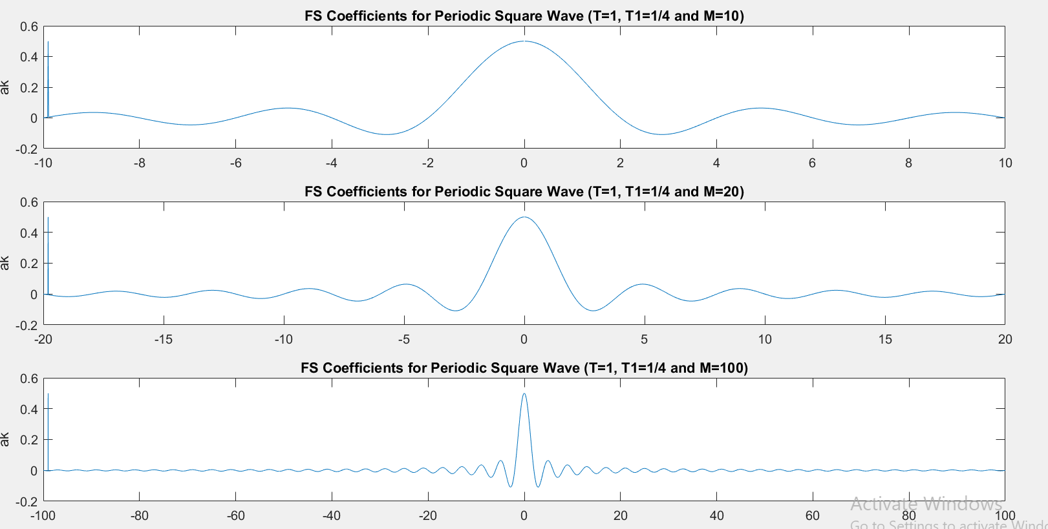

**Observations:**

My Observations are.

1. As the number of terms (M) increases, the reconstructed square wave becomes closer to the ideal square wave in terms of shape.
2. However, even with a large number of terms, the reconstructed square wave exhibits Gibbs oscillations near the discontinuities (edges) of the square wave.
3. The Gibbs oscillations manifest as overshoots or ringing effects at the edges of the square wave.
4. Increasing the number of terms (M) helps to reduce the magnitude of the Gibbs oscillations, but they still persist.
5. The Gibbs phenomenon is a characteristic of Fourier series and occurs due to the inability of a finite number of harmonics to accurately represent the sharp transitions of a square wave.

**Discussion and Conclusion:**

In summary, the Gibbs phenomenon refers to the persistent oscillations near the discontinuities of a reconstructed signal using a truncated Fourier series. These oscillations are evident in the reconstructed square wave, even with an increasing number of terms.

## Task # 06:

Given the following FS coefficients:

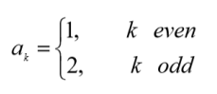

Plot the coefficients & reconstructed signal. Take the terms for reconstructed signal to be M = 10, 20, & 50. What effect do you see when M is varied?

**Problem Analysis:**

To make a signal for custom ak values.

**Algorithm:**

* Write code
* Execute Code
* Record Results

**Output / Graphs / Plots / Results:**

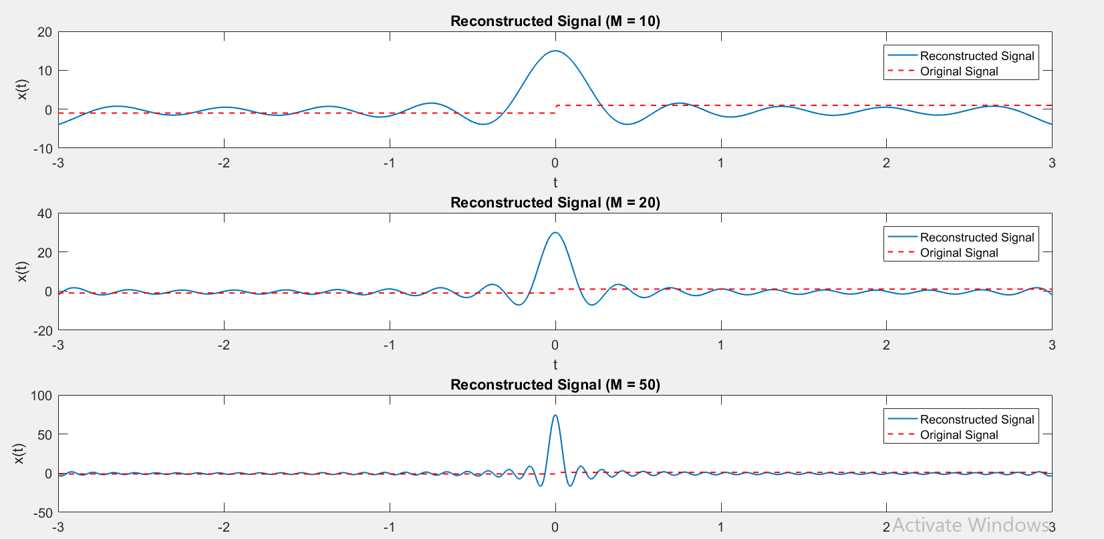

**Discussion and Conclusion:**

Reconstructed the signal using custom ak values. Gibbs Phenomenon can be observed when M is increased.

## Task # 07:

Given the following FS coefficients:

Plot the coefficients & reconstructed signal. Take 10 terms (M=10) for reconstructed signal.

**Problem Analysis:**

To make a signal for custom ak values.

**Algorithm:**

* Write code
* Execute Code
* Record Results

**Output / Graphs / Plots / Results:**

**Discussion and Conclusion:**

Reconstructed the signal using custom ak values.